Valon Haslem
CPSC 321-01, Fall 2025
Project 3: ER Diagram
11-19-2025
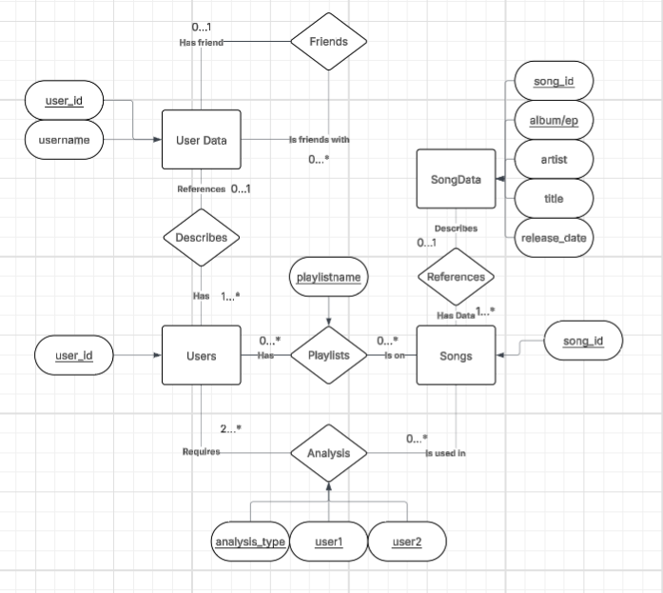
UC1 – Construct Playlist - Add
UC2 – Delete Playlist - Remove
UC3 – Remove Song from Playlist - Remove
UC4 – Modify Playlist Name - Update
UC5 – Modify Song List - Update
UC6 – Commit Playlist - Add
UC7 – User Genre Data Analysis - Analyze
UC8 – User Song and Playlist Count Data Analysis – Analyze
UC9 – Lookup song, find users/playlists combo with song - Search
UC10 – Lookup artist, find users/playlists with corresponding artist – Search
I will build the application using a simple one-page html document in a GitHub repository. I will run the dynamic sql script in the html page using the pyscript library, and I will source all my data using the Spotify API, which I already have access to from a previous project. The implemented services will be in the form of buttons with parameters that can be filled out by the user (specifying friends, playlist names, song name, etc) allowing the user to achieve the aforementioned use cases. To summarize, these cases allow the user to construct playlists via intersection with friends’ songs, commit these playlists to their own library, look up songs/artists in their friend’s Spotify data, and analyze the listening habits of their friends or themselves. Note that upon initialization of the website, the script will construct the songs, playlists, and users relations.

